Inborn Errors & Nitrogen Metabolism

Dr. Spicer

[dspicer@une.edu](mailto:dspicer@une.edu)

1

# Objectives

* Describe the role of glutamine and alanine in the transport of nitrogen from peripheral tissues to

the liver

* Describe conditions that would lead to a positive or negative nitrogen balance
* Describe the importance of nitrogen transport mechanisms in extrahepatic tissues (e.g. muscle, brain, kidney).
* Define essential and conditionally-essential amino acids, and describe changes in requirements during growth and metabolic stress (e.g. burns, infections, healing)
* Define nitrogen balance and explain how it is affected by dietary intake, growth, stress and

disease.

* Describe the products and regulation of the fructose and galactose metabolic pathways
* Distinguish the following disease states associated with Inborn Errors of Metabolism, including the enzyme deficiency, relation of the deficiency to the buildup of secondary metabolites, and clinically relevant information related to the disease state: Phenylketonuria, Maple Syrup Urine Disease, Essential Fructosuria, Hereditary Fructose Intolerance, and Classical and Nonclassical Galactosemia.

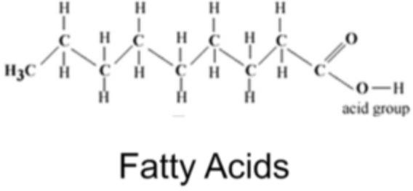

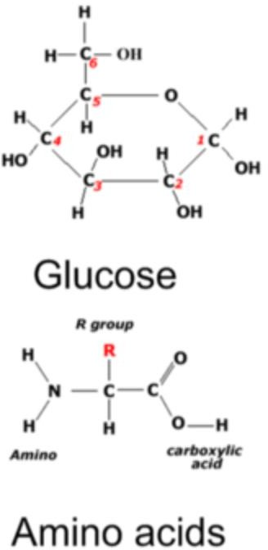

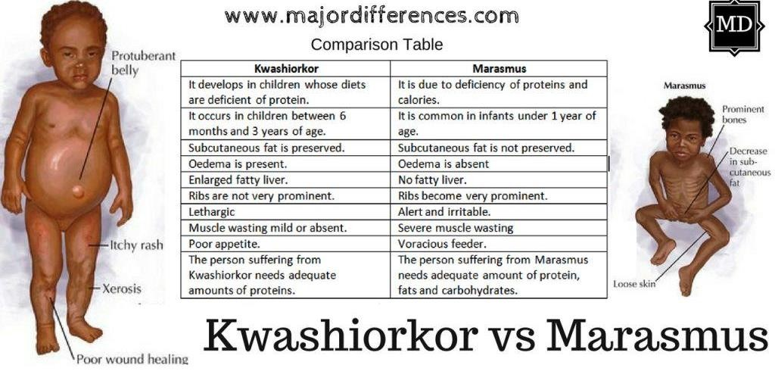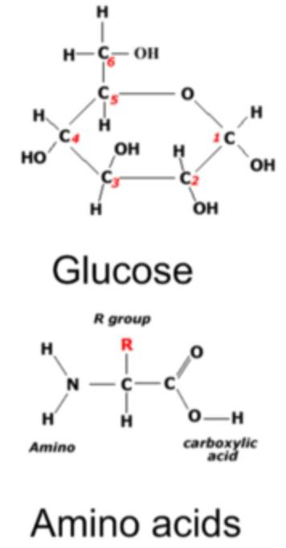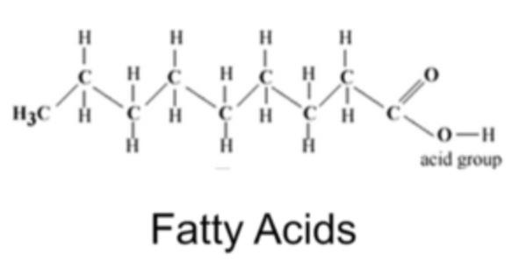

A 1-year-old-male is brought to the physician by his mother because of concerns of weight loss, edema of the abdomen, and upper and lower extremities. The child is lethargic and irritable when aroused. The mother says that after weaning the child from breastfeeding, she had placed the child on the BRAT diet consisting of bananas, white rice, applesauce and toast as a result of concern for food allergies.



## Amino Acid Pool

6



A 15-year-old girl, accompanied by her mother, presents to her primary care physician complaining of fatigue and sleeplessness for 6 months' duration. The doctor notes the patient is quite petite and is wearing an oversized, baggy dress. There are no physical findings. She is found to be 88% of the minimum weight requirements for her age and height. Her mother is concerned as her daughter has been eating little and exercising daily. Which metabolic flux is most prevalent in this patient?

1. Glucose → fatty acids
2. Glucose → glycogen
3. Fatty acids → triacylglycerol
4. Protein → amino acids

## Nitrogen Balance

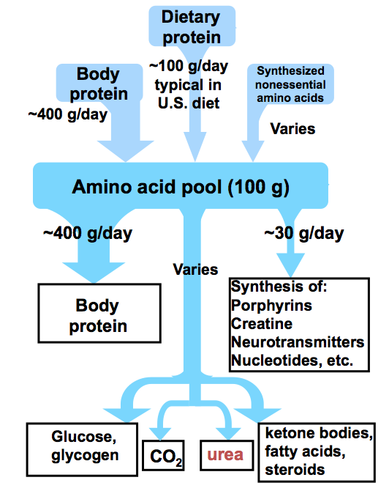Positive balance

Negative balance

Protein in > Protein out

* Pregnancy
* Growth
* Muscle building
* Recovery from illness

Protein in < Protein out

* Protein insufficiency in diet
* Starvation
* Stress
* Hypercatabolic state
  + Infection
  + Fever
  + Surgery
  + cachexia

## Glucogenic and Ketogenic Amino Acids

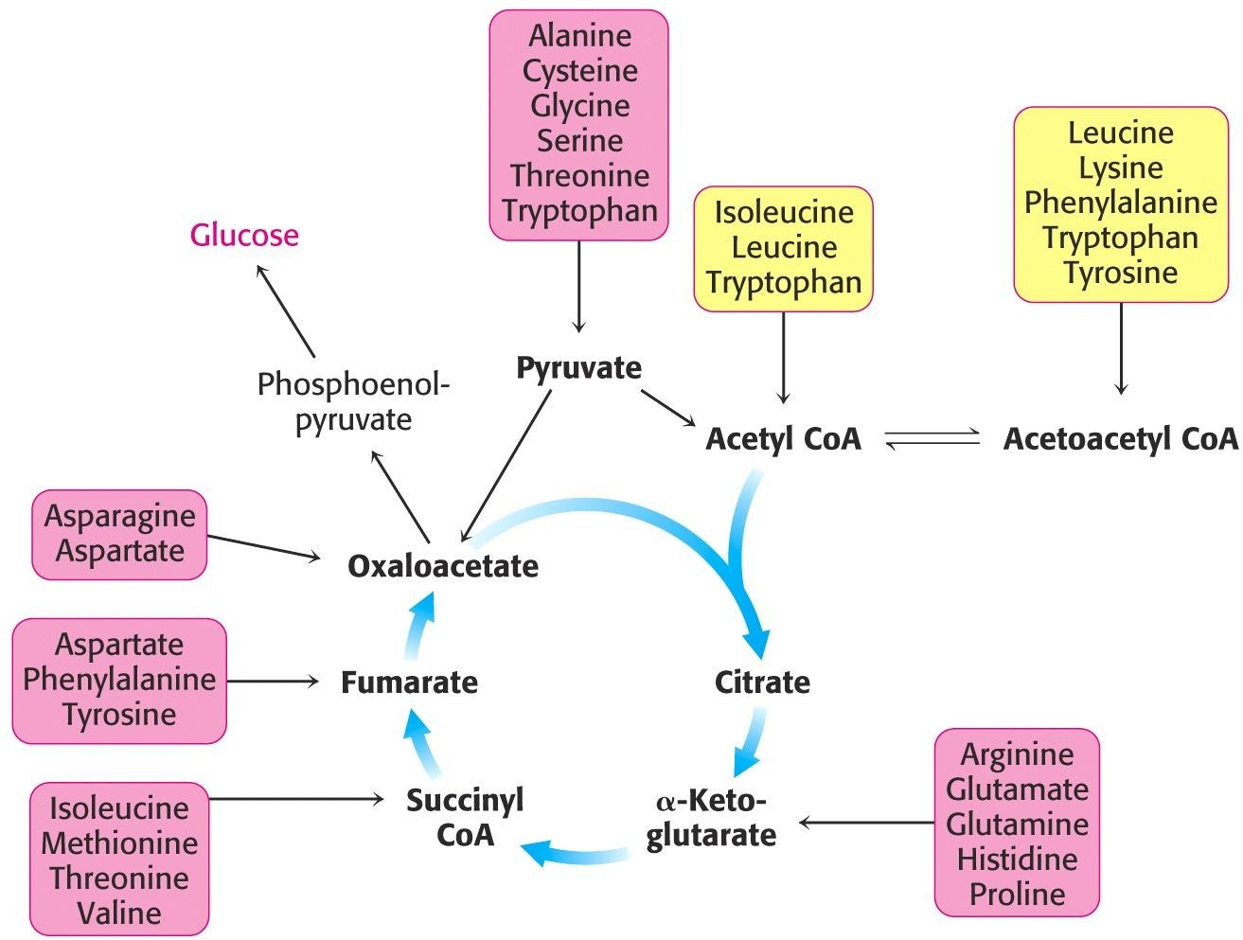

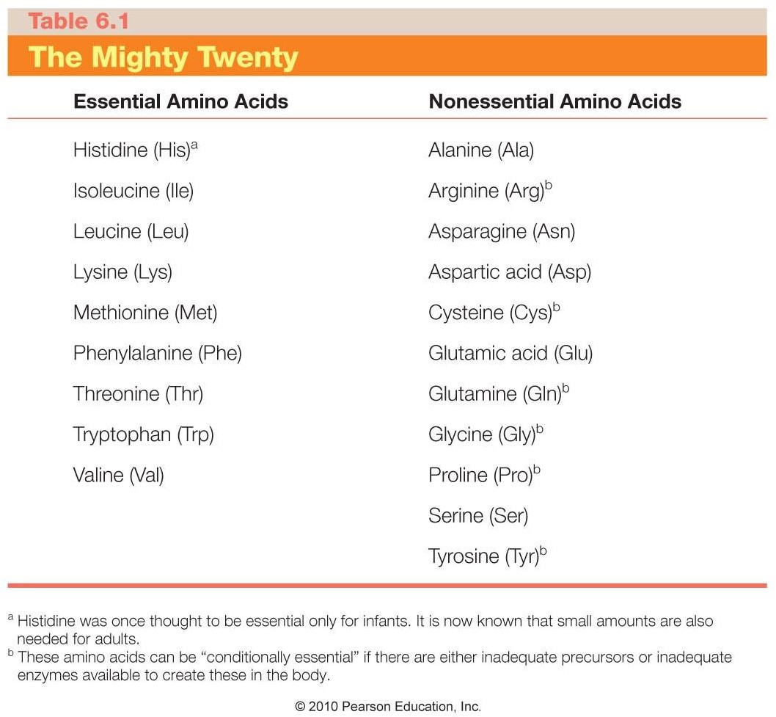

### Glutamine and alanine are used for transporting nitrogen

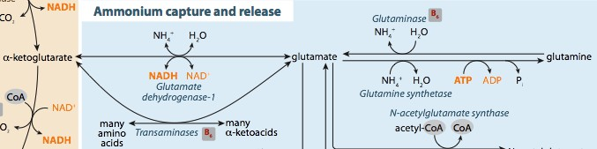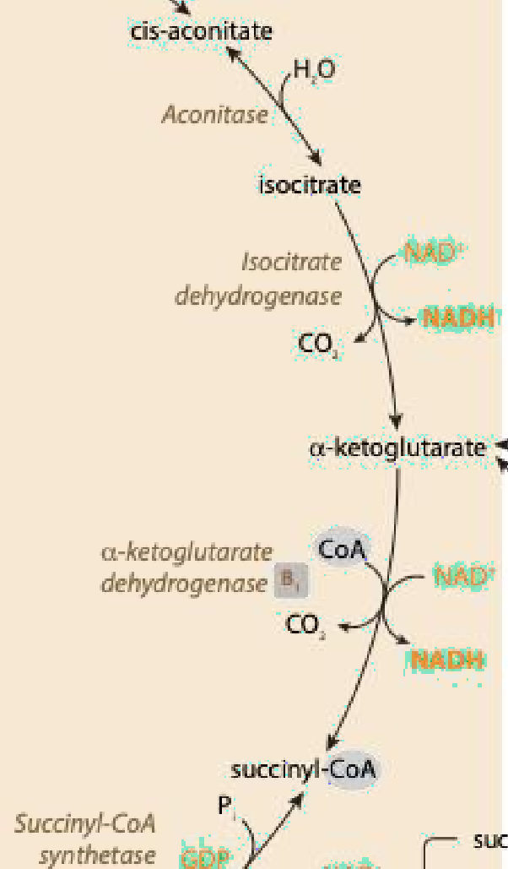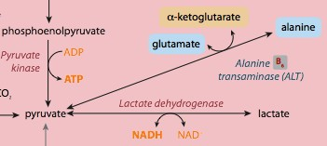

**TCA Cycle**

**TCA Cycle**

Glutaminase

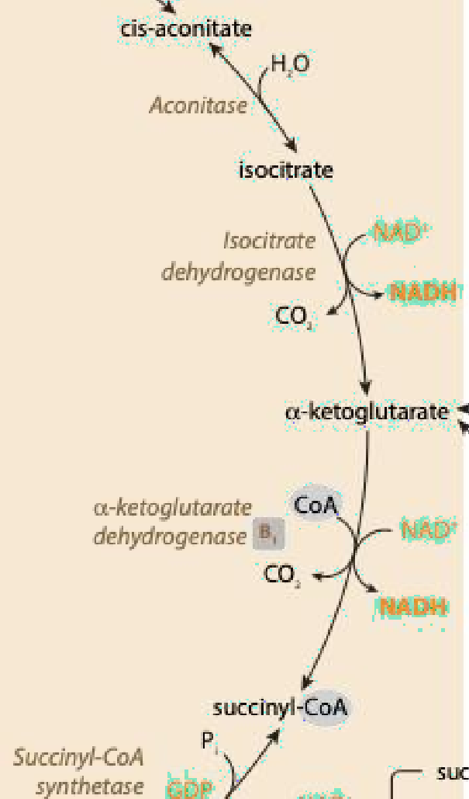

* Removes ammonia from glutamine
* Highest expression in liver, kidney, brain, and small intestine

page1image7607792

**TCA Cycle**

Glutamate dehydrogenase



* Primary role is to release ammonia from glutamate
* Highest expression in liver, kidney, and small intestine, but

present in most cells

* Can fix free ammonia to form glutamate

**TCA Cycle**

Glutamine synthetase



* Expressed in all cells, but highest in the brain, kidney, and liver
* Generates glutamine from glutamate by fixing free ammonia
* Uses ATP
* Inhibited by high AMP

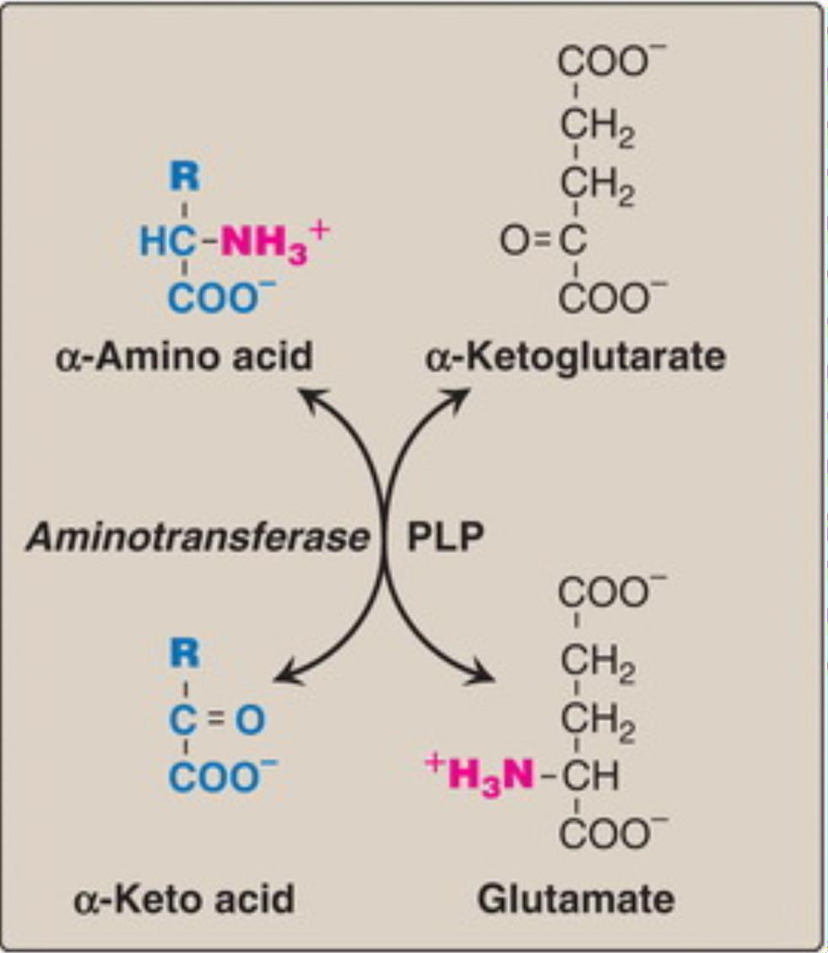AST and ALT

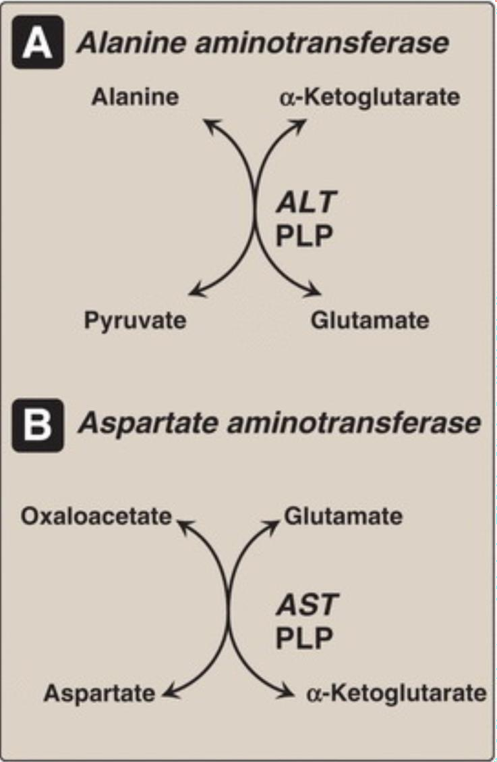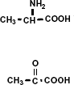

Alanine

Pyruvate

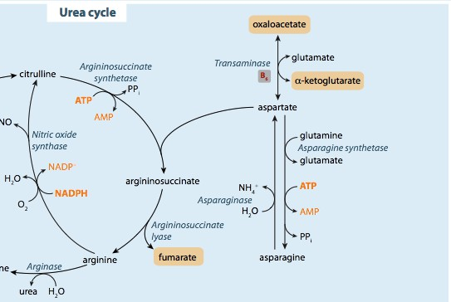AST and ALT



**AST/ALT Ratio**



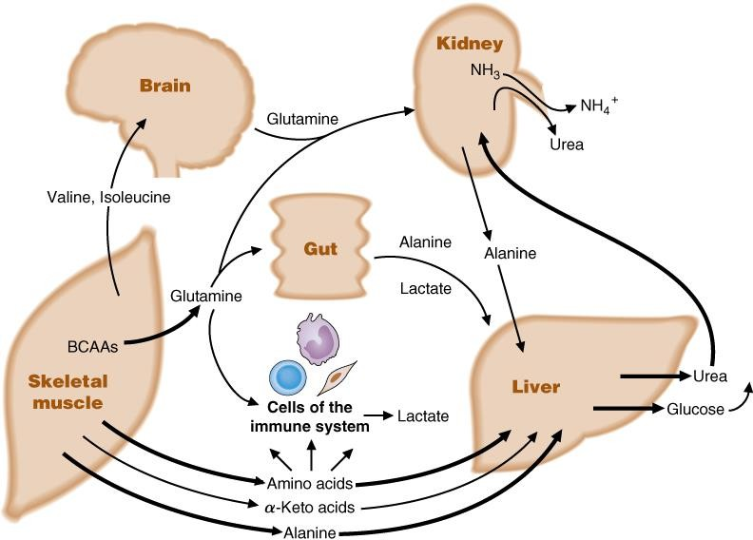Nitrogen Transport

Glutamine

Inactive muscle Active muscle

and other tissues

BCAA

BCKA

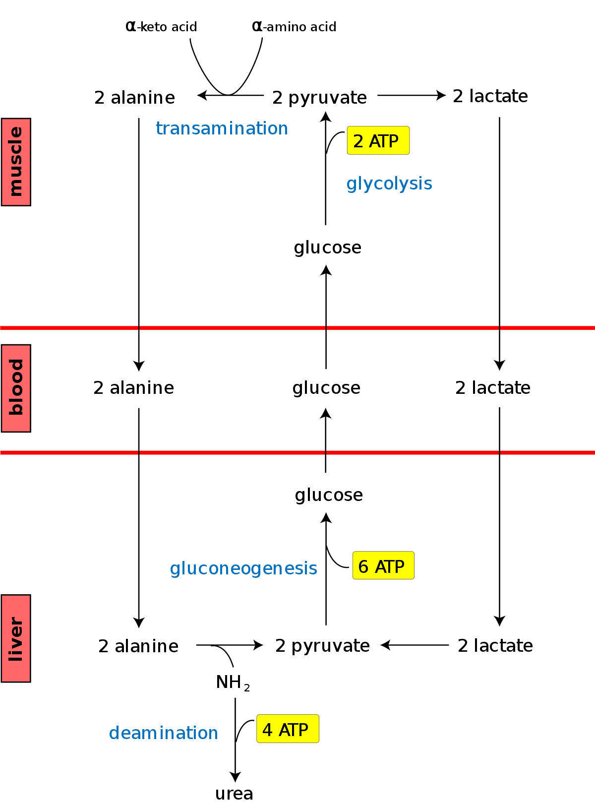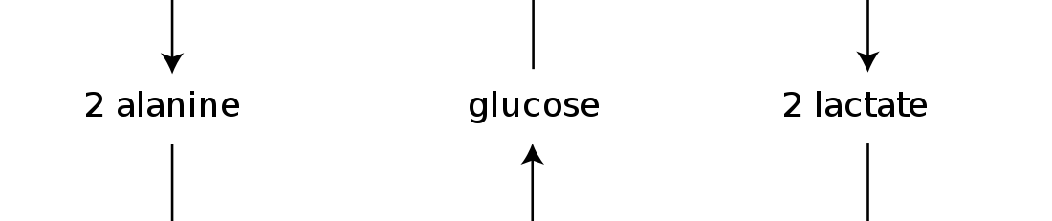

-ketoglutarate

glutamate

18

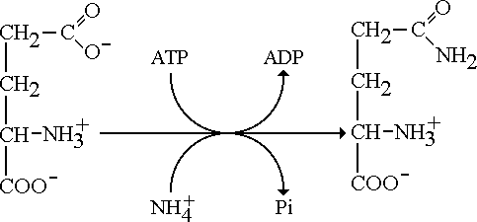

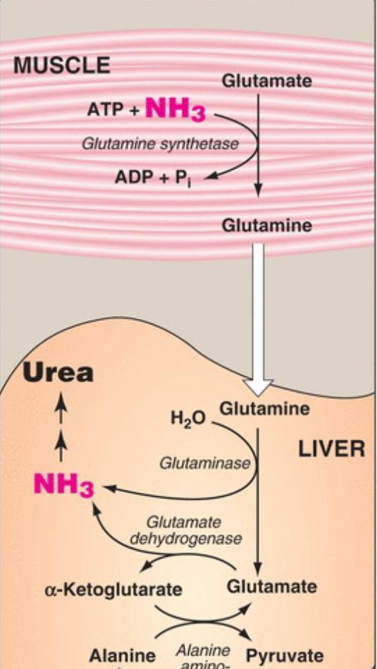Glutamate Glutamine

### Glutamate is a neurotransmitter, so glutamine is used as a nitrogen transporter

Glu

NH4+

Glu

Gln

NH4+

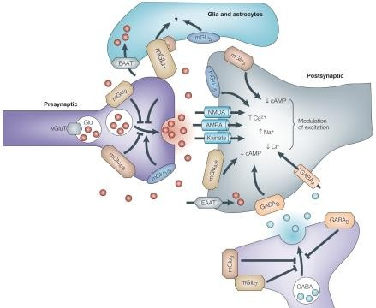

19

A 15-year-old girl, accompanied by her mother, presents to her primary care physician complaining of fatigue and sleeplessness for 6 months' duration. The doctor notes the patient is quite petite and is wearing an oversized, baggy dress. She is found to be 88% of the minimum weight requirements for her age and height. Her mother is concerned as her daughter has been eating little and exercising daily. Which amino acids would be found in the highest concentration in the serum?

1. Branched chain amino acids
2. Alanine and Glutamine
3. Arginine and Ornithine
4. Glutamate and Aspartate

Ammonium Ion Ammonia



Physiological pH (approximate)

pKa of ammonia (approximate)



**Therefore…**

**and**



**at physiologic pH (7.4) 98.6% will be NH4+ and

### Glutamate is a neurotransmitter, so glutamine is used as a nitrogen transporter

Glu

NH4+

Glu

Gln

NH4+



22

## Role of glutamine in the brain

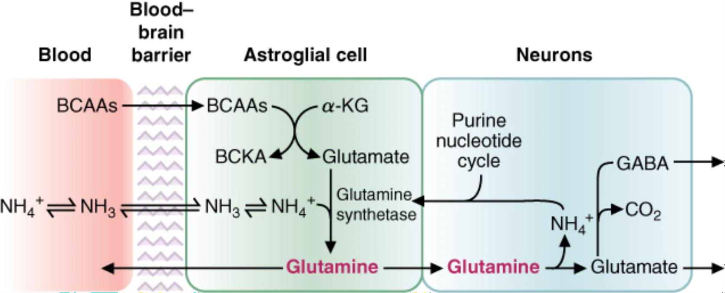

Role of glutamine in the brain. Glutamine serves as a nitrogen transporter in the brain for the synthesis of many different neurotransmitters. Different neurons convert glutamine to γ-

4

aminobutyric acid (GABA) or to glutamate. Glutamine also transports excess NH into the blood.

+ from the brain

α-KG, α-ketoglutarate; BCAAs, branched-chain amino acids; BCKA, branched-chain α-keto acids.

## Role of glutamine in the brain



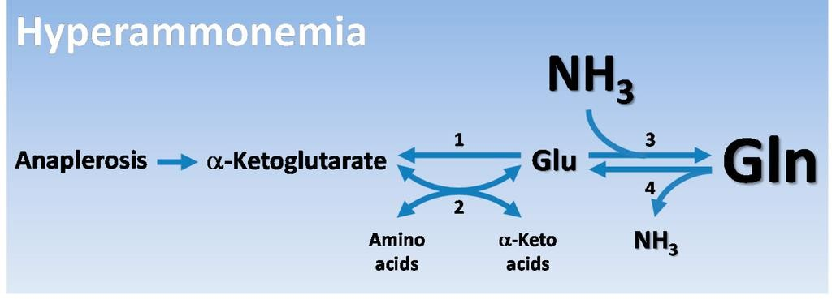

**Cataplerosis**

Role of glutaminase in the kidney during acidosis

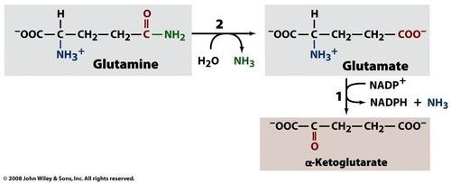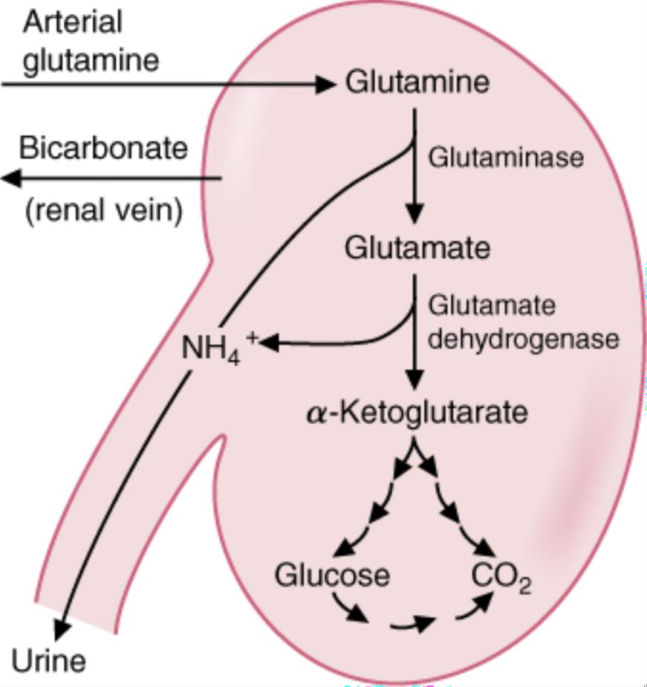

H

-

3

Renal tubule cells preferentially oxidize glutamine. During metabolic acidosis, it is the major fuel for the kidney.

Conversion of glutamine to α-ketoglutarate generates NH + ,

4

and α-ketoglutarate can form 2 bicarbonate molecules..

Inborn

Errors of

Metabolism

**For the inborn errors listed below write out the following;**

1. Genetic defect
2. Most common age of presentation
3. Fed or fasting presentation (if fed, what food does it correlate with)
4. Presenting symptoms

Explain why these symptoms have occurred

1. Diagnostic lab findings
2. Dietary treatment
   1. MCAD deficiency
   2. Primary carnitine deficiency
   3. Refsum disease
   4. Hereditary fructose intolerance
   5. Essential fructosuria
   6. Classic galactosemia
   7. Galactokinase deficiency
   8. Phenylketonuria (PKU)
   9. Maple syrup urine disease
   10. Urea cycle defects

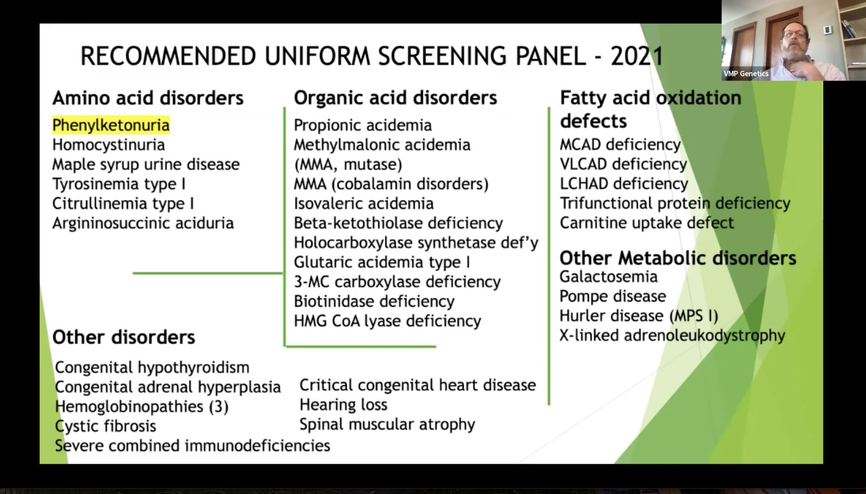

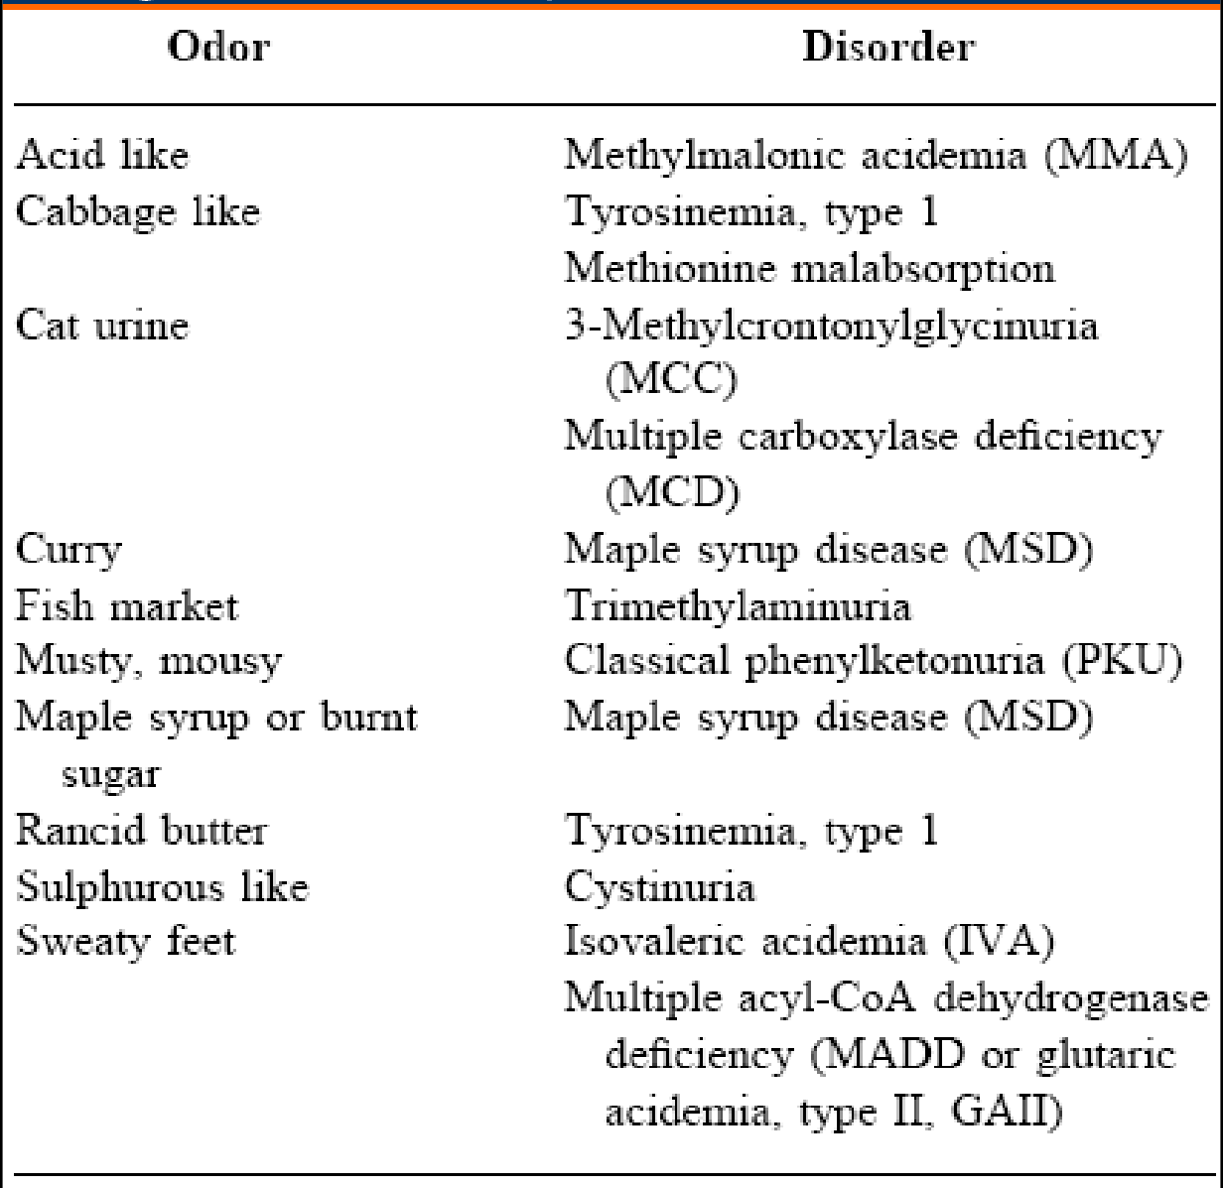Urine odors associated with IEMs

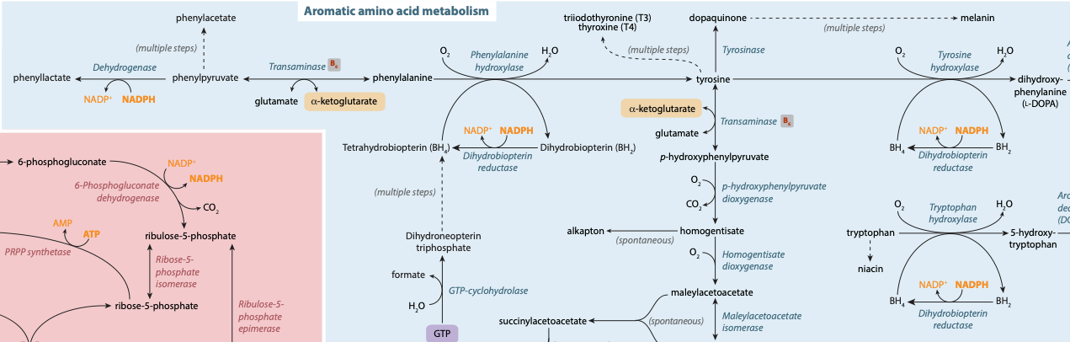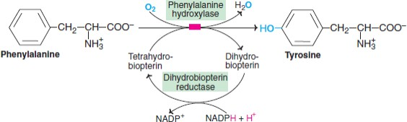

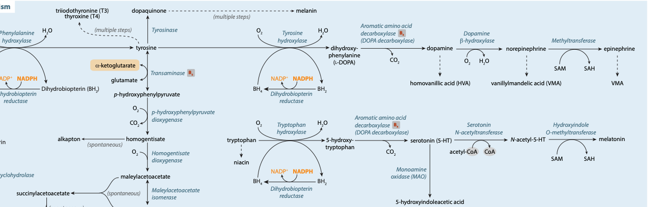

# PKU Treatment

*Palynzic*

NH + +

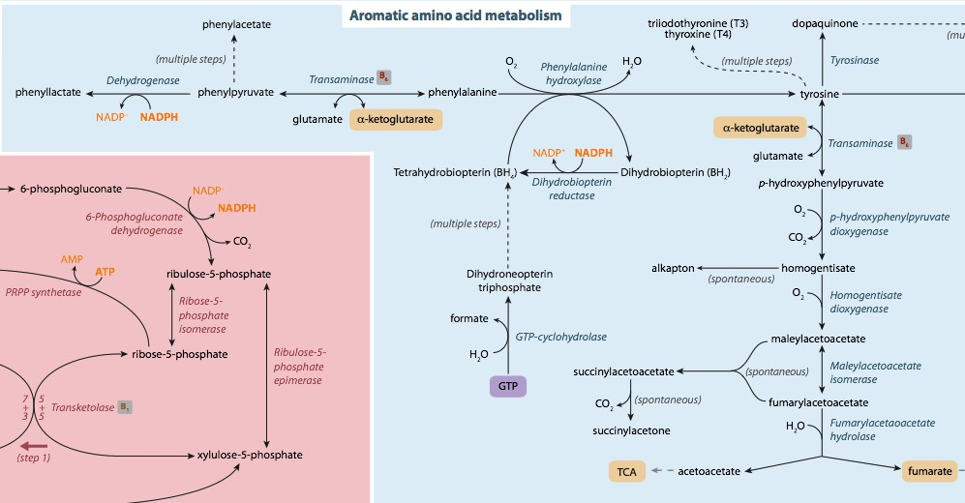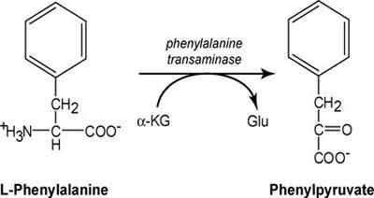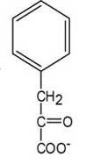

4

H2 **Trans-cinnamic acid**

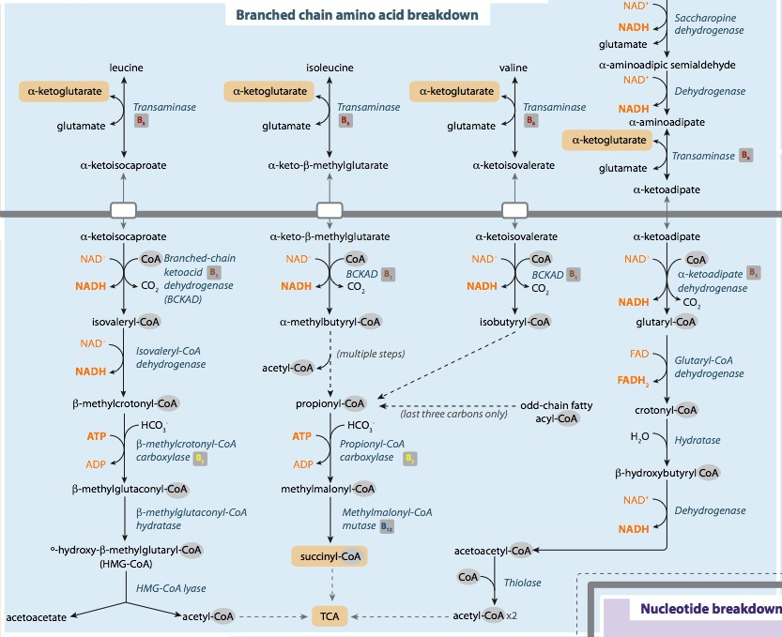

32

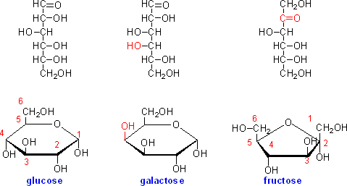

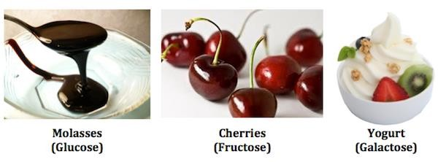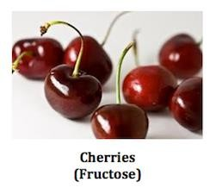

Malt

## Sugar Metabolism

Fructose Metabolism

35

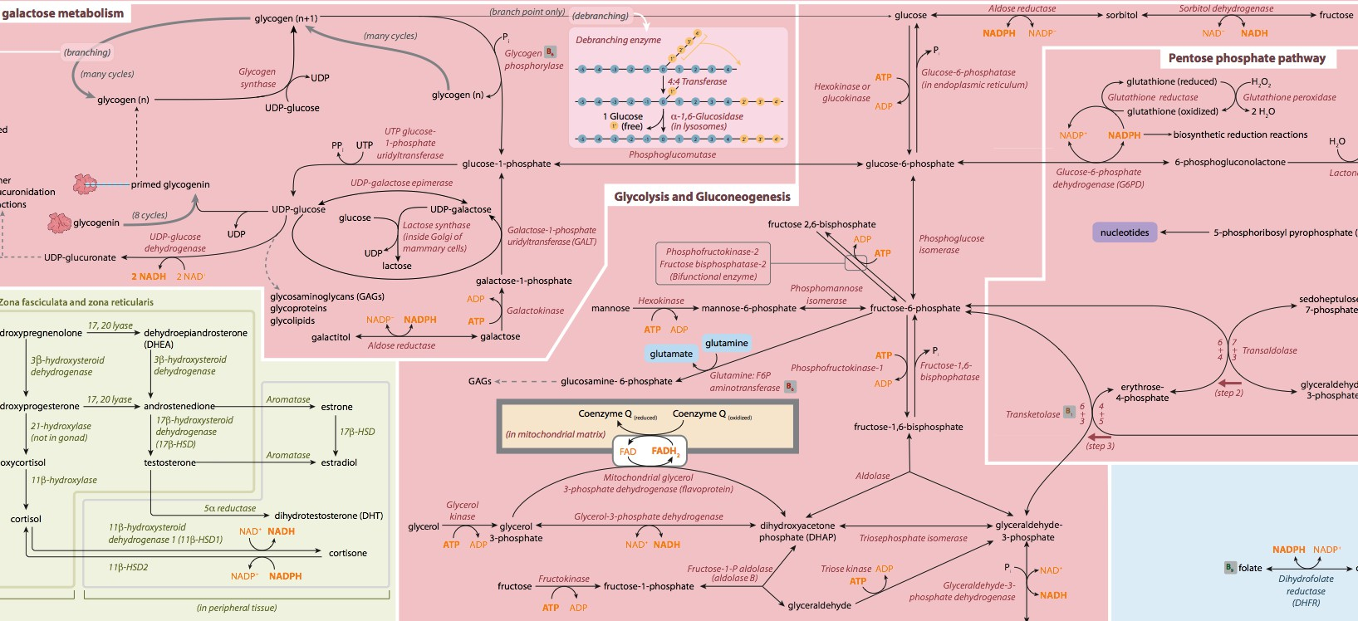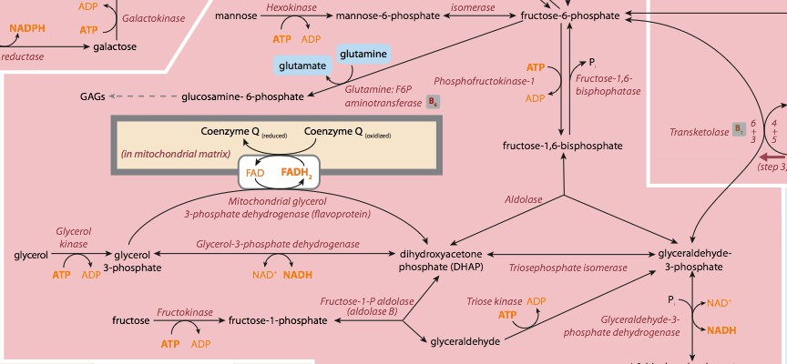

## Fructose metabolism

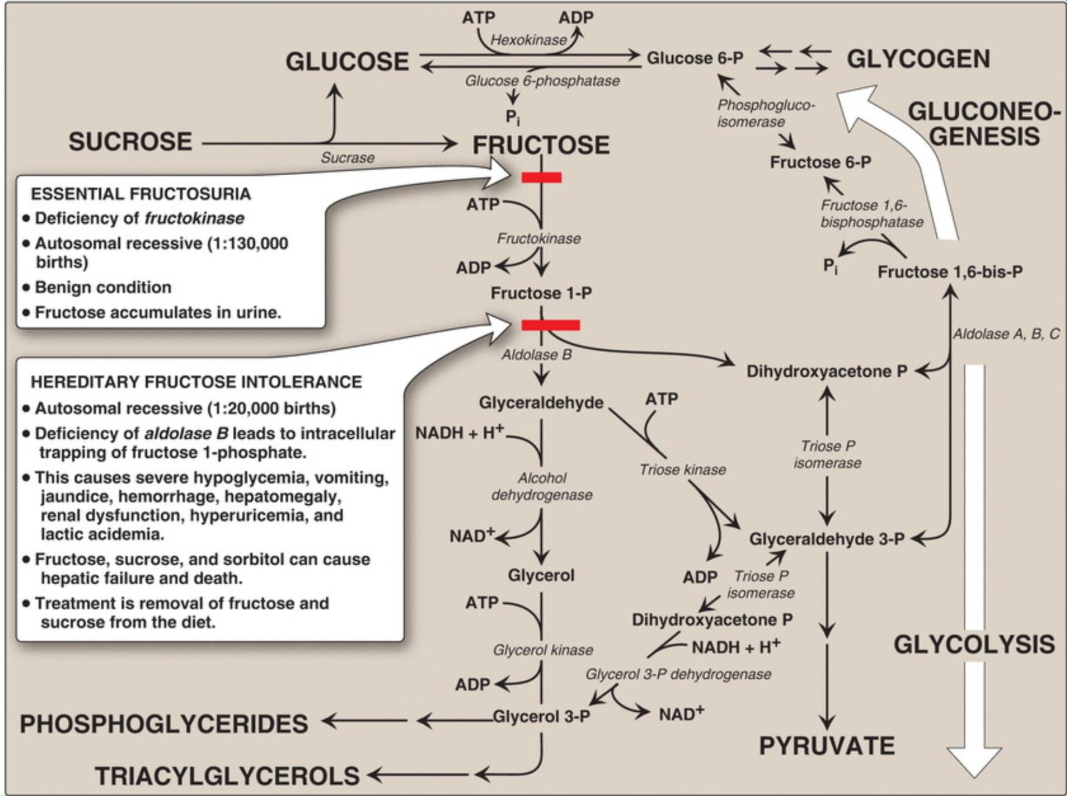36

## Fructose Metabolism

Galactose metabolism

**Diabetes**

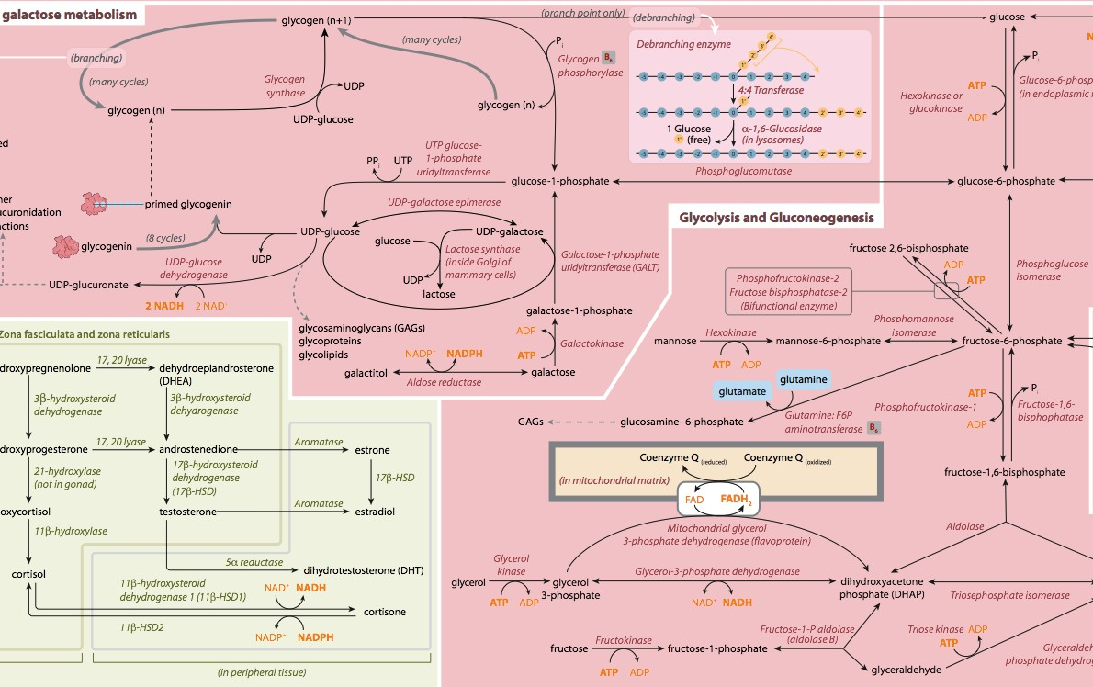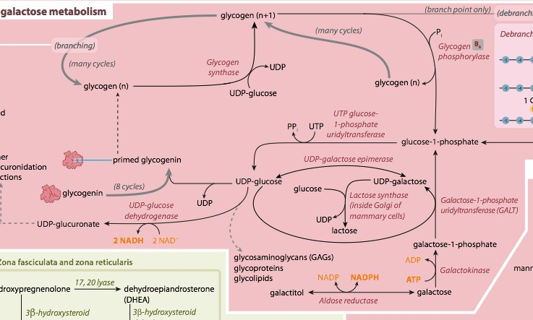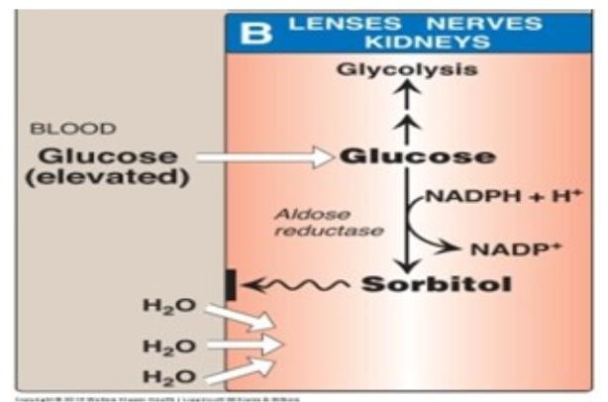

## CoverGalactose metabolism

A 4-day-old Hispanic female presents with respiratory distress, vomiting and refusal to feed. She is lethargic and hypotonic and appears dehydrated. The family history is unremarkable. The patient’s urine has the smell of burnt sugar.

Principle Laboratory Findings:

|  |  |  |
| --- | --- | --- |
| **Test** | **Result** | **Reference Interval** |
| pH | 7.10 | 7.35 - 7.45 |
| pCO2 | 21  (2.79) | 34 – 50 mm/Hg  (4.52 – 6.65 kPa) |
| HCO3 | 6 | 16 – 24 mmol/L |
| Sodium | 151 | 139 – 146 mmol/L |
| Chloride | 116 | 96 – 106 mmol/L |
| AGAP | 28 | 5 – 14 |

Diagnostic laboratory findings:

– Metabolic workup:

Test Result Reference Interval

***Amino acid***

|  |  |  |
| --- | --- | --- |
| ***analysis****:* |  | |
| -Leucine | 4375 mol/L | 47 – 160 |
| -Isoleucine | 588 mol/L | 26 – 91 |
| -Valine | 1155 mol/L | 64 – 336 |

-Alloisoleucine (abnormal metabolite)

***Organic acid analysis:***

- Presence of: 2-hydroxy-isovaleric acid, 2-hydroxy-isocaproic acid and 2- hydroxy-3-methylvaleric acid

* + 1. Classic Galactosemia
    2. Dihydrobiopterin Reductase Deficiency
    3. Essential Fructosuria
    4. Galactokinase Deficiency (non-classic galactosemia)
    5. Hereditary Fructose Intolerance
    6. Maple Syrup Urine Disease
    7. Phenylketonuria

An 8-month-old first born girl is evaluated by her pediatrician in the emergency department for an abrupt change in her mental status after several episodes of vomiting and lethargy. The parents report that she has become listless over the past several weeks. Her growth and development have been normal over the first 6 months. Now, however, as her diet is advanced to soft solids and juice in the past 6 weeks, the parents note these changes in behavior. Laboratory testing reveals a serum glucose level of 30 mg/dl (normal >80 mg/dL) and urinalysis is positive for reducing sugar but negative for glucose. What is the likely diagnosis?

1. Classic Galactosemia
2. Dihydrobiopterin Reductase Deficiency
3. Essential Fructosuria
4. Galactokinase Deficiency (non-classic galactosemia)
5. Hereditary Fructose Intolerance
6. Maple Syrup Urine Disease
7. Phenylketonuria

## Fructose Metabolism

A 3-month-old girl is developing cataracts. Other than not having a social smile or being able to track objects visually, all other aspects of the girl's examination are normal. Tests on the baby's urine are positive for reducing sugar but negative for glucose.

What is the likely diagnosis?

1. Classic Galactosemia
2. Dihydrobiopterin Reductase Deficiency
3. Essential Fructosuria
4. Galactokinase Deficiency (non-classic galactosemia)
5. Hereditary Fructose Intolerance
6. Maple Syrup Urine Disease
7. Phenylketonuria

## CoverGalactose metabolism

A 1-year-old girl is brought to her pediatrician’s office with concerns about her development. She had an uncomplicated birth outside of the United States at term. The mother reports that the baby is not achieving the normal milestones for a baby of her age. She also reports an unusual odor to her urine and some areas of hypopigmentation on her skin and hair. The urine collected is found to have a “mousy” odor.

What is the most likely diagnosis?

1. Classic Galactosemia
2. Dihydrobiopterin Reductase Deficiency
3. Essential Fructosuria
4. Galactokinase Deficiency (non-classic galactosemia)
5. Hereditary Fructose Intolerance
6. Maple Syrup Urine Disease
7. Phenylketonuria

Two infants, patient A and B, are being evaluated for suspected PKU after newborn screening results demonstrated phenylalanine (Phe) level of 6.6 and 6.8 mg/dL (normal=1- 2mg/dL), respectively. BH4 loading tests are performed on both patients and the results are given below. For the loading test, BH4 tablets are given 30 minutes before a meal. Blood is drawn before, and 4 and 8 hours after BH4 loading and Phe levels are determined. Which patient likely has a deficiency in phenylalanine hydroxylase?

47



Patient A

Patient B

**Time (hrs) after BH4 administration**

1. Patient A
2. Patient B



B

BH4

BH2

**Phe mg/dL**

A



A previously healthy 2-month-old female presents with jittery spells several hours after breastfeeding. Her mother reports she has not given the baby anything to eat other than breastmilk since birth. The baby has only recently been sleeping for more than 2 hours between feedings and that’s when the mother reports these symptoms started. Laboratory results are consistent with hypoglycemia (low blood glucose) but are otherwise unremarkable. Epinephrine is administered and there is no increase in blood glucose but there is an increase in blood lactate (Hint: think of what pathways would be activated by this hormone).

Physical exam reveals a liver edge 4 cm below the right costal margin. Percussion of the right chest and abdomen confirms hepatomegaly (enlarged liver).

Blood glucose levels increase after breastfeeding but she cannot maintain blood glucose levels within a normal range during fasting.

Based on the information above, which of the following is the most likely diagnosis of this patient?

*Hereditary fructose intolerance Galactosemia*

*Glycogen storage disease Type 1a*